Game #1 Planning💀

The game will begin with a small explanation about how it works, pre-made video.

Round #1:

Min-number of players: 4, max-amount of players: 8.

Part #1 – 02:00:

The players will receive a prompt. The prompt will be a uncomplete sentence that each player will need to complete in the funniest way that he can think of.

Part #2 – 00:30 * number of sentences:

Every sentence will be displayed on the screen and the players will need to anonymously vote on which sentence was funnier. Every vote will be worth points according to the game.

Points:

Each vote – 10 points

Consensus - **number of players * 20**.

Round #2:

Same as last round only all the points are doubled.

Points:

Each vote – 20 points

Consensus - **number of players * 40**.

End of game:

At the end of the game the top 3 players will be displayed with their point sum, the rest will be listed on the side.

**Scripts📜**

Intro to the game - video:

Hey yo! What’s up? J.k. I don’t care. I am the narrator.

I am here to explain how this game works.

Now how does it work?  
So here, first each player will receive an uncomplete sentence which he will have to complete in the funniest way he can think of.

After all the players have finished, then our special computer will process them and will show the answers that you guys gave and will let your fellow quote on quote friends decide if you are in-fact the funniest person in the room.

Round two – voice over:

Guess what? All the points are now DOUBLED!

Results – voice over:

Now let’s see who’s the funniest and who’s the most boring person in the room.

Protocol🤝

Type: text-based

Headers:

Type - mandatory: ANSR, PRMT, VOTE, LGIN (answer, prompt, vote, log-in)

Blen – optional: int with the length of the body. If empty, then there is no body.

Separator: ^

Examples:

1. type:LGIN^blen:5^Ophir
2. type:PRMPT^blen:57^A new tv show about baby eating crocodiles is called ___
3. type:ANSWR^blen:13^Diaper Danger
4. type:ANSWR^
5. type:VOTE^blen:96^A new tv show about baby eating crocodiles is called ___^Diaper Danger^Tiny Jaws  
     
   ^ - separator
6. type:VOTE^blen:1^1

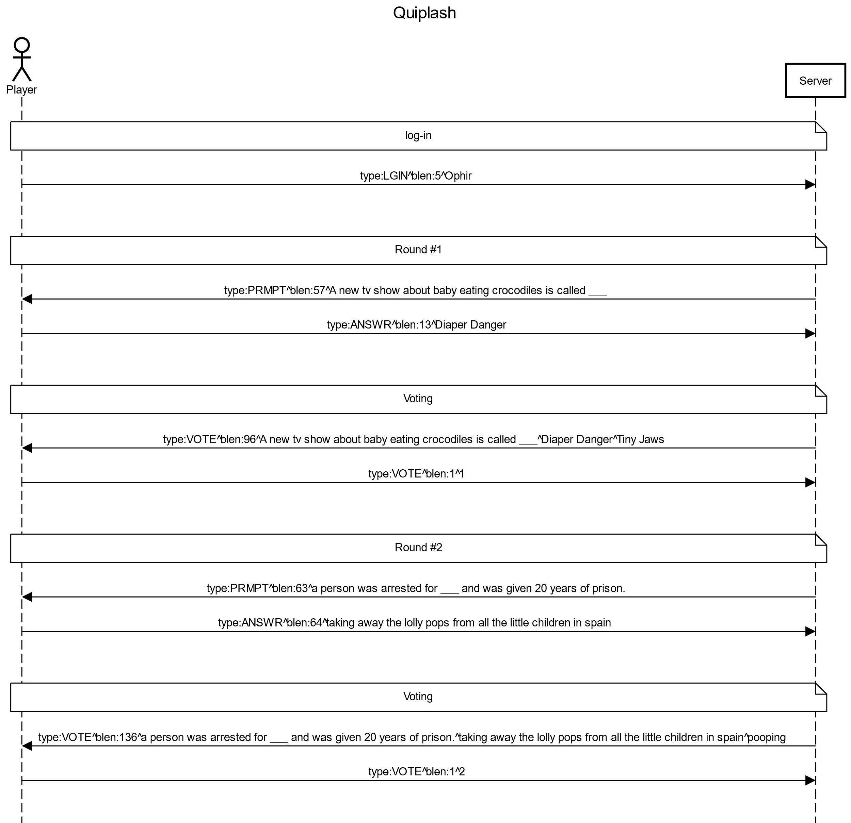Sequence Diagram: